1 run

training 1 epoch...

2539.6661398410797 seconds used......

1 training finished! average train loss: 0.6776517299980722

total clf loss: 766.7104743216187 total adv loss: 490.47666930407286

evaluating...

Confusion matrix, without normalization

[[ 255 425 342]

[ 65 5140 202]

[ 53 440 10272]]

Normalized confusion matrix

[[0.24951076 0.41585127 0.33463796]

[0.01202145 0.95061957 0.03735898]

[0.00492336 0.0408732 0.95420344]]

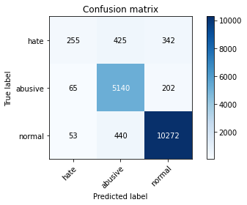

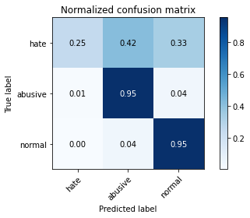

precision recall f1-score support

hate 0.68 0.25 0.37 1022

abusive 0.86 0.95 0.90 5407

normal 0.95 0.95 0.95 10765

accuracy 0.91 17194

macro avg 0.83 0.72 0.74 17194

weighted avg 0.90 0.91 0.90 17194

average eval_loss: 0.280022491640303, accuracy: 0.9111899499825521

training 2 epoch...

2537.5196149349213 seconds used......

2 training finished! average train loss: 0.5706473403718986

total clf loss: 644.0209026243538 total adv loss: 413.8392954482697

evaluating...

Confusion matrix, without normalization

[[ 256 402 364]

[ 83 5107 217]

[ 42 400 10323]]

Normalized confusion matrix

[[0.25048924 0.39334638 0.35616438]

[0.01535047 0.94451637 0.04013316]

[0.00390153 0.03715745 0.95894101]]

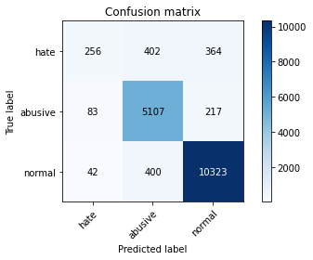

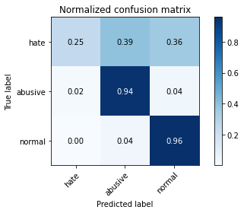

precision recall f1-score support

hate 0.67 0.25 0.36 1022

abusive 0.86 0.94 0.90 5407

normal 0.95 0.96 0.95 10765

accuracy 0.91 17194

macro avg 0.83 0.72 0.74 17194

weighted avg 0.90 0.91 0.90 17194

average eval_loss: 0.28066898065207657, accuracy: 0.9122949866232407

training 3 epoch...

2536.002015352249 seconds used......

3 training finished! average train loss: 0.4875412825740565

total clf loss: 554.0010073333979 total adv loss: 351.68397949868813

evaluating...

Confusion matrix, without normalization

[[ 313 359 350]

[ 139 5006 262]

[ 75 366 10324]]

Normalized confusion matrix

[[0.30626223 0.35127202 0.34246575]

[0.02570742 0.92583688 0.04845571]

[0.00696702 0.03399907 0.95903391]]

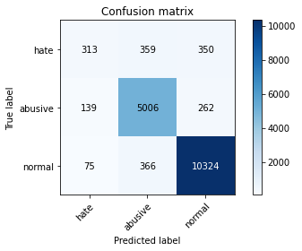

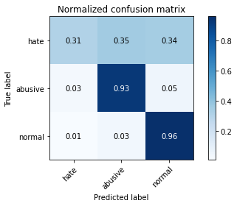

precision recall f1-score support

hate 0.59 0.31 0.40 1022

abusive 0.87 0.93 0.90 5407

normal 0.94 0.96 0.95 10765

accuracy 0.91 17194

macro avg 0.80 0.73 0.75 17194

weighted avg 0.90 0.91 0.90 17194

average eval_loss: 0.2996318165191211, accuracy: 0.9097941142258927

training 4 epoch..

2 run

training 1 epoch...

Confusion matrix, without normalization

[[ 256 434 332]

[ 48 5085 274]

[ 90 317 10358]]

Normalized confusion matrix

[[0.25048924 0.42465753 0.32485323]

[0.00887738 0.94044757 0.05067505]

[0.00836043 0.02944728 0.96219229]]

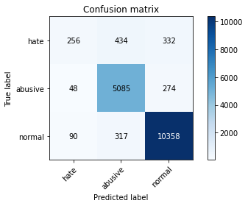

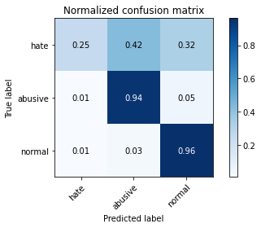

precision recall f1-score support

hate 0.65 0.25 0.36 1022

abusive 0.87 0.94 0.90 5407

normal 0.94 0.96 0.95 10765

accuracy 0.91 17194

macro avg 0.82 0.72 0.74 17194

weighted avg 0.90 0.91 0.90 17194

average eval_loss: 0.2709648201133796, accuracy: 0.9130510643247645

training 2 epoch...

2496.6369462013245 seconds used......

2 training finished! average train loss: 0.5503433081485727

total clf loss: 627.2652981411666 total adv loss: 396.0350468363613

evaluating...

Confusion matrix, without normalization

[[ 422 316 284]

[ 238 4996 173]

[ 178 429 10158]]

Normalized confusion matrix

[[0.41291585 0.30919765 0.2778865 ]

[0.04401701 0.92398742 0.03199556]

[0.01653507 0.03985137 0.94361356]]

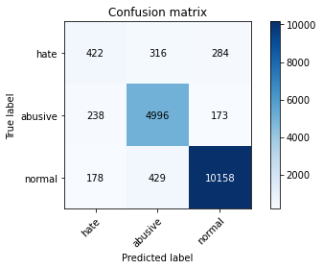

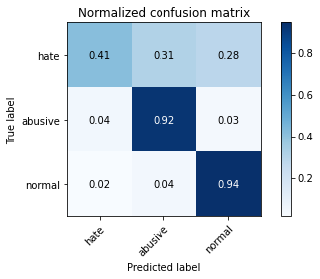

precision recall f1-score support

hate 0.50 0.41 0.45 1022

abusive 0.87 0.92 0.90 5407

normal 0.96 0.94 0.95 10765

accuracy 0.91 17194

macro avg 0.78 0.76 0.77 17194

weighted avg 0.90 0.91 0.90 17194

average eval_loss: 0.28491577443688415, accuracy: 0.9058974060718855

training 3 epoch...

2495.086753129959 seconds used......

3 training finished! average train loss: 0.4490927471040801

total clf loss: 516.5073606637307 total adv loss: 320.8514175262535

evaluating...

Confusion matrix, without normalization

[[ 311 371 340]

[ 143 5001 263]

[ 75 332 10358]]

Normalized confusion matrix

[[0.30430528 0.3630137 0.33268102]

[0.0264472 0.92491215 0.04864065]

[0.00696702 0.03084069 0.96219229]]

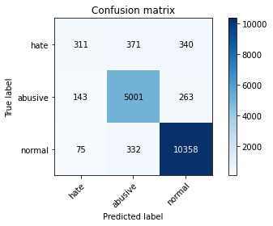

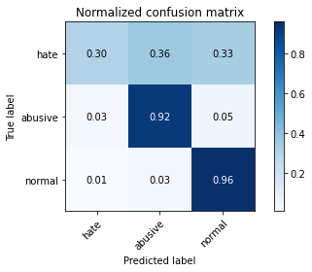

precision recall f1-score support

hate 0.59 0.30 0.40 1022

abusive 0.88 0.92 0.90 5407

normal 0.94 0.96 0.95 10765

accuracy 0.91 17194

macro avg 0.80 0.73 0.75 17194

weighted avg 0.90 0.91 0.90 17194

average eval_loss: 0.2949957979084967, accuracy: 0.9113644294521345

training 4 epoch...

2495.3678047657013 seconds used......

4 training finished! average train loss: 0.36018918142966366

total clf loss: 414.48829115368426 total adv loss: 257.21980422048364

evaluating...

Confusion matrix, without normalization

[[ 350 363 309]

[ 205 4942 260]

[ 160 369 10236]]

Normalized confusion matrix

[[0.34246575 0.35518591 0.30234834]

[0.03791382 0.91400037 0.04808581]

[0.01486298 0.03427775 0.95085927]]

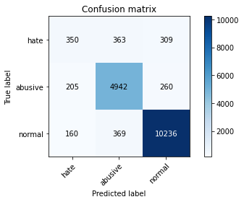

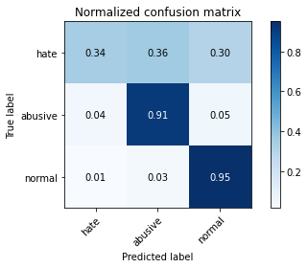

precision recall f1-score support

hate 0.49 0.34 0.40 1022

abusive 0.87 0.91 0.89 5407

normal 0.95 0.95 0.95 10765

accuracy 0.90 17194

macro avg 0.77 0.74 0.75 17194

weighted avg 0.90 0.90 0.90 17194

average eval_loss: 0.33219445929970853, accuracy: 0.9031057345585669

training 5 epoch...